Artificial Intelligence Lab

Lab Manual 4



Department of Cyber Security
HITEC University Taxila

Experiment # 04

Implementation of OOP Concepts in Python

Objective

- To understand basics of Object and Classes.
- Implementing Constructors and its types.
- Implementing inheritance

Software
  - Python 3.9.1, PyCharm or VS Code IDE.

Theory:

OOP Concept

Like other general-purpose languages, python is also an object-oriented language since its beginning. Python is an object-oriented programming language. It allows us to develop applications using an Object-Oriented approach. In Python, we can easily create and use classes and objects.
Major principles of object-oriented programming system are given below.
- Object
- Class
- Method
- Inheritance
- Polymorphism
- Data Abstraction
- Encapsulation

Object
The object is an entity that has state and behavior. It may be any real-world object like the mouse, keyboard, chair, table, pen, etc.

Class
The class can be defined as a collection of objects. It is a logical entity that has some specific attributes and methods. For example: if you have an employee class then it should contain an attribute and method, i.e. an email id, name, age, salary, etc.
Syntax Example

class Employee:
id = 10;
name = "Usama"

def display (self):
print(self.id, self.name)

emp = Employee()
emp.display()
Here, the self is used as a reference variable which refers to the current class object. It is always the first argument in the function definition. However, using self is optional in the function call.

Creating an instance of the class
A class needs to be instantiated if we want to use the class attributes in another class or method. A class can be instantiated by calling the class using the class name. The syntax to create the instance of the class is given below.
<object-name> = <class-name> (<arguments>)
Create a class that takes name and ids of three students as arguments in constructor. Then create a method to print all data

Python Inheritance
Inheritance is an important aspect of the object-oriented paradigm. Inheritance provides code reusability to the program because we can use an existing class to create a new class instead of creating it from scratch.
In inheritance, the child class acquires the properties and can access all the data members and functions defined in the parent class. A child class can also provide its specific implementation to the functions of the parent class. In this section of the tutorial, we will discuss inheritance in detail. In python, a derived class can inherit base class by just mentioning the base in the bracket after the derived class name. Consider the following syntax to inherit a base class into the derived class.

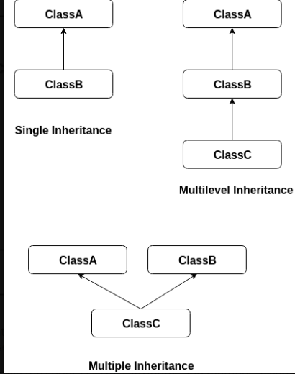

Syntax

class Animal:
def speak(self):
print("Animal Speaking")

class Dog(Animal):
def bark(self):
print("dog barking")

d = Dog()
d.bark()
d.speak()

Python multi-level inheritance
Multi-Level inheritance is possible in python like other object-oriented languages. Multi- level inheritance is archived when a derived class inherits another derived class. There is no limit on the number of levels up to which, the multi-level inheritance is archived in python.

Syntax

class Animal:
def speak(self):
print ("Animal Speaking")

class Dog (Animal):
def bark(self):
print ("dog barking")

class DogChild(Dog):
def eat(self):
print ("Eating bread...")

d = DogChild()
d.bark()
d.speak()
d.eat()

Example
Python Multiple inheritance
Python provides us the flexibility to inherit multiple base classes in the child class.

class Calculation1:
def Summation (self, a, b):
return a + b;

class Calculation2:
def Multiplication (self, a, b):
return a*b;

class Derived (Calculation1, Calculation2):
def Divide (self, a, b):
return a/b;

d = Derived ()
print(d.Summation(10,20))
print(d.Multiplication(10,20))
print(d.Divide(10,20))

Task:
Employee Management:
- Create a Person class with attributes/variables “name” and “age”.
- Create a Job class with attributes/variables “designation” and “salary”.
- Create an Employee class that inherent the above both classes
- Implement a method to display employee details.
Lab Task:
- Write a Python class named Circle constructed by a radius and two methods which will compute the area and the perimeter of a circle.
- Write a Python class to implement pow(x, n). Do not use built-in math.pow() function for this code. Also handle this code for all +ve as well as -ve numbers.
- Write a Python code for the following figure

